Commerce Bank Project User Guide

Team 4

April 14, 2020

Team Members
Harrison R. Lara
Daudi Williams
Madison Hubbard

Contents
Contents 2
1 Introduction 3
2 Quick Start Guide 3
3 System Requirements 7
4 Main Scenarios of Use 7
4.1 View Recent Transactions 7
4.2 Add a Transaction 9
4.3 Export Transactions 10
4.4 Viewing and Removing Notifications 11
4.5 Notification Preferences 12

Introduction
The Commerce Bank application allows users to easily view their bank accounts, set notifications, review and manage individual account data and export transactions. This document will provide instructions for using the application to view their account snapshot, viewing notification, managing notifications, view individual account details, exporting transactions, adding a transaction, creating an account and logging into their account.

Quick Start Guide
- Navigate to https://banking.commercebank.com/CBI/Auth/Login
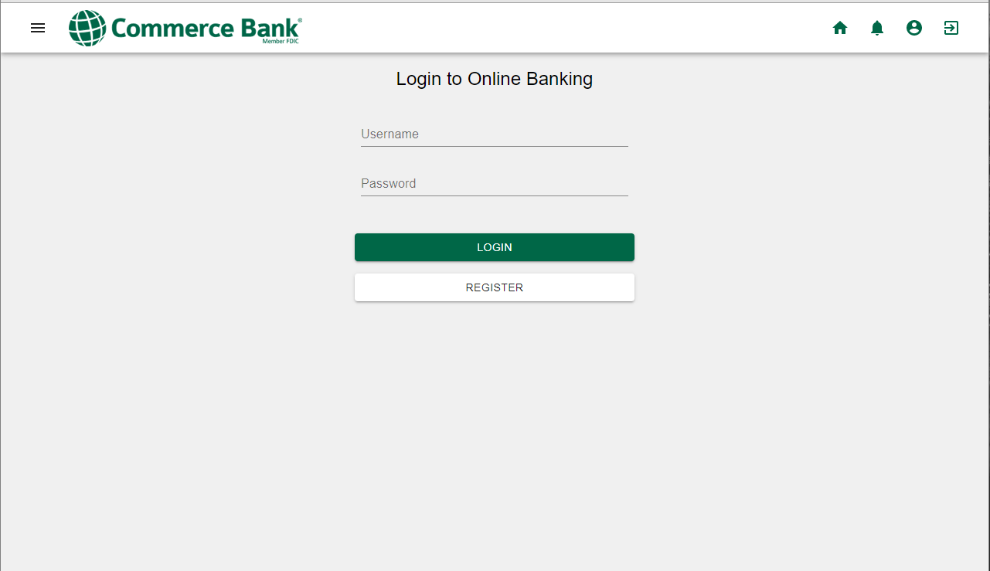

- Enter username and password. If you do not have an account, click Register (skip to step 4).
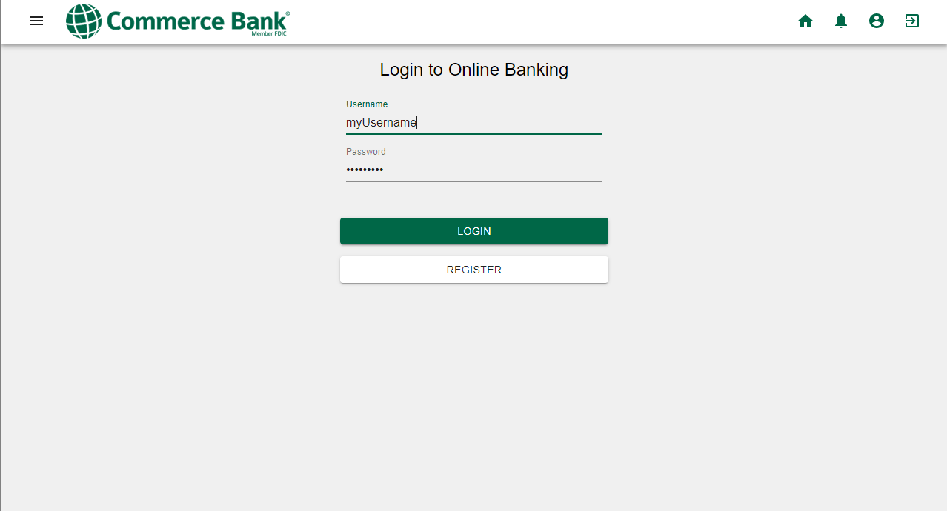
- Tap the Login button.
- Fill out the create account form to and click Register to create your account.
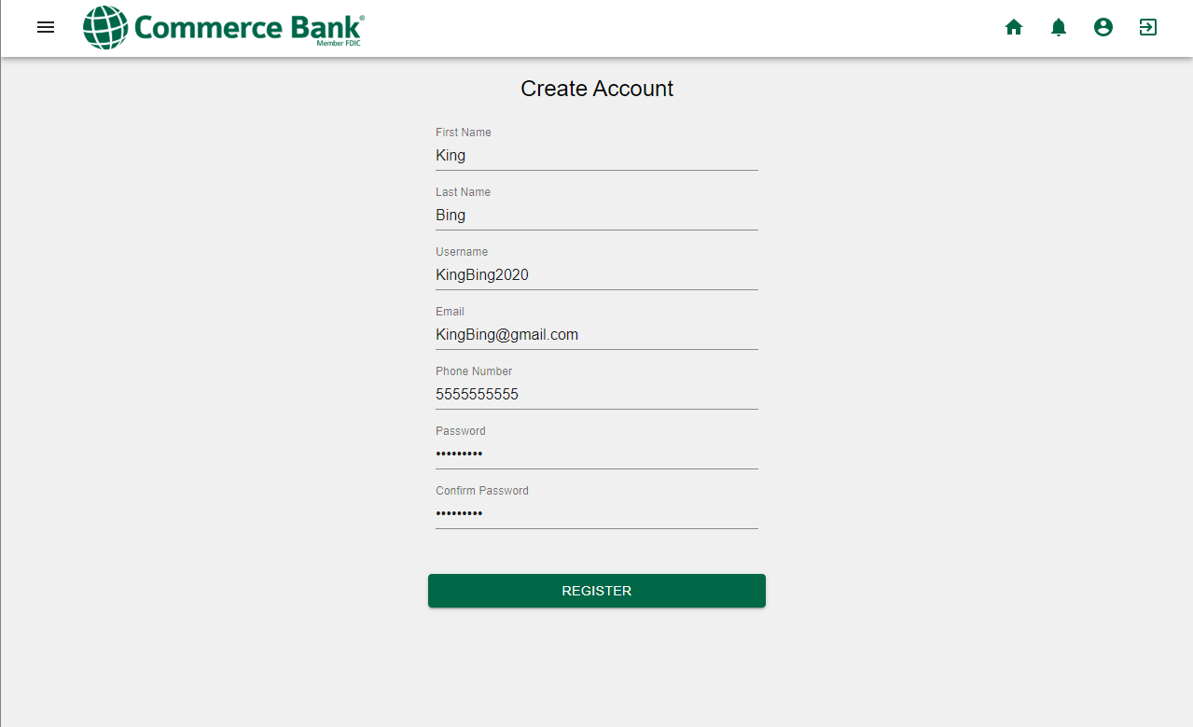

- A snapshot of your accounts will be available on the dashboard.
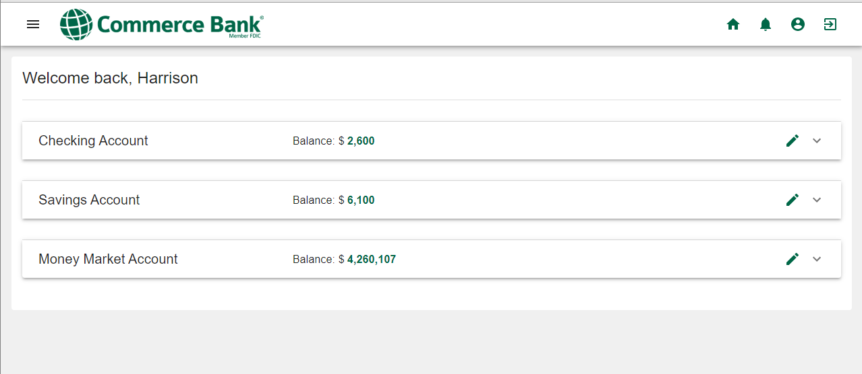
- To view an account in detail, click the pencil icon corresponding to the selected account.
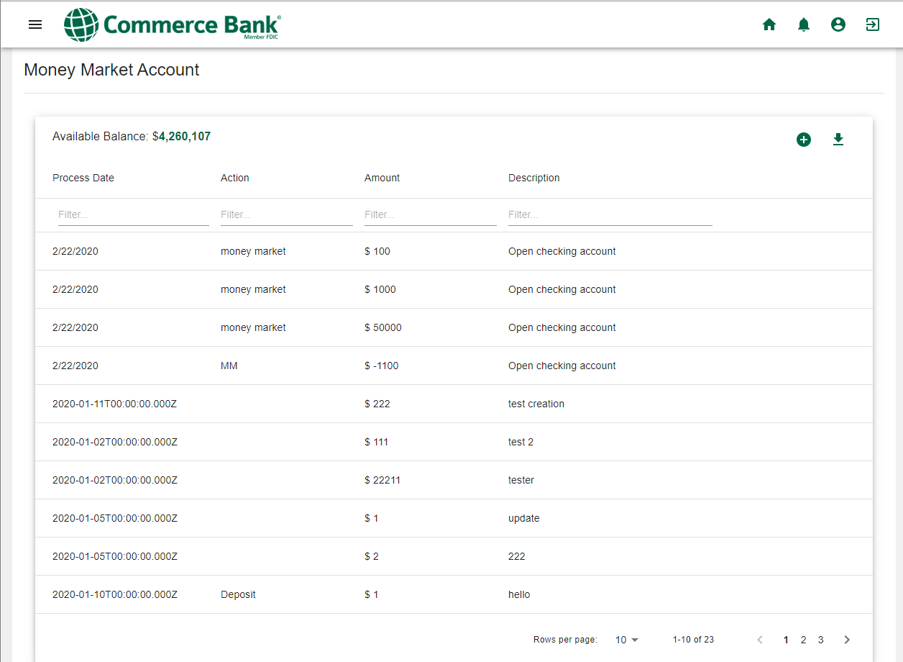

- To find a specific transaction, you can use the filter, click the column name to sort or you page through the transactions.
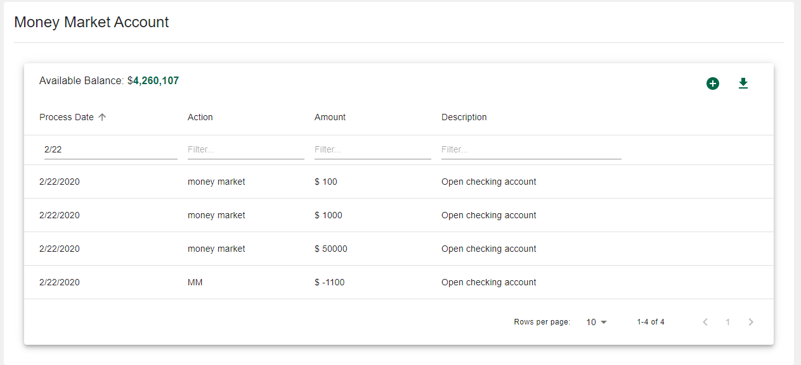
- To quickly navigate the site, click the Menu icon at the top left.
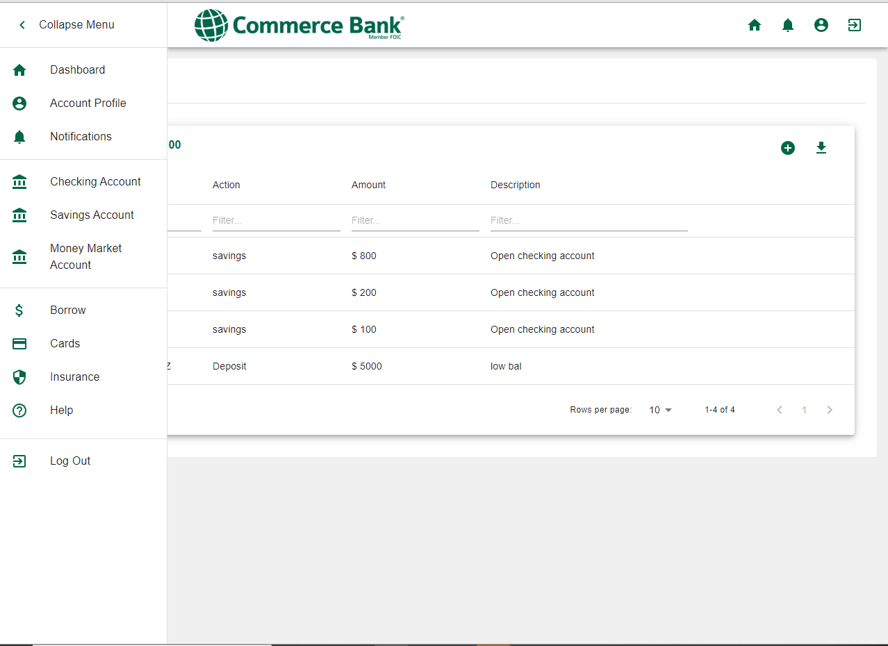

System Requirements
The Commerce Bank application can be used from any device that can access the internet.

Main Scenarios of Use

View Recent Transactions
- Navigate to Commerce Bank.
- Enter your username and password.
- Click the Login button.
- Click the Pencil icon on the desired account.

- Recent transactions will be displayed.

Add a Transaction
- Navigate to Commerce Bank.
- Enter your username and password.
- Click the Login button.
- Click the Pencil icon on the desired account.
- Click the Plus icon at the top right of the grid
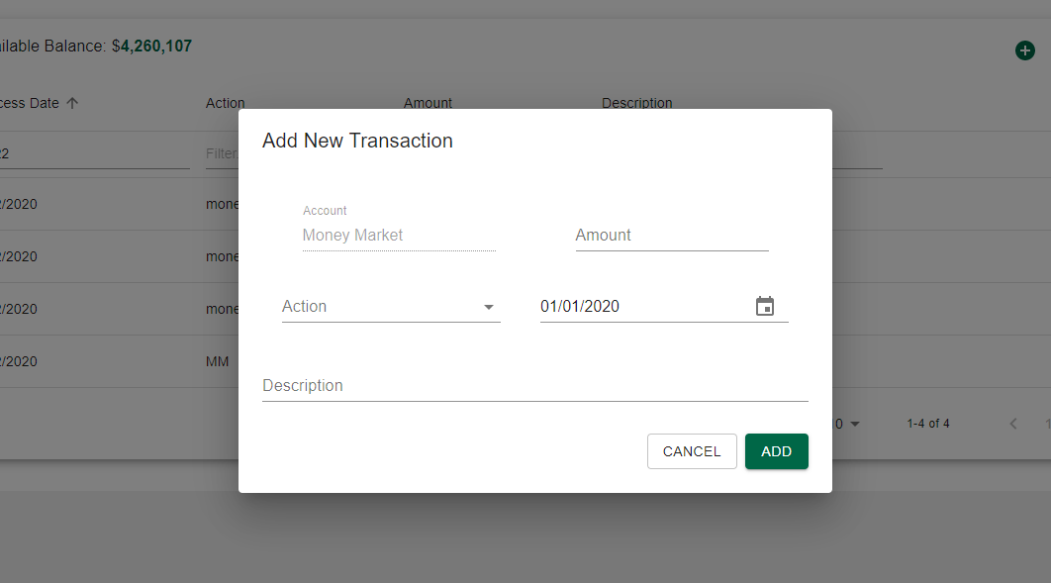
- Enter transaction information and click OK to add.

Export Transactions
- Navigate to Commerce Bank.
- Enter your username and password.
- Click the Login button.
- Click the Pencil icon on the desired account.
- Click the Download icon at the top right of the grid
- A spreadsheet with your account data has been downloaded. The name of the spreadsheet will match the account name.
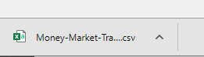

Viewing and Removing Notifications
- Navigate to Commerce Bank.
- Enter your username and password.
- Click the Login button.
- After logging in, any notifications triggered will be visible on the dashboard.
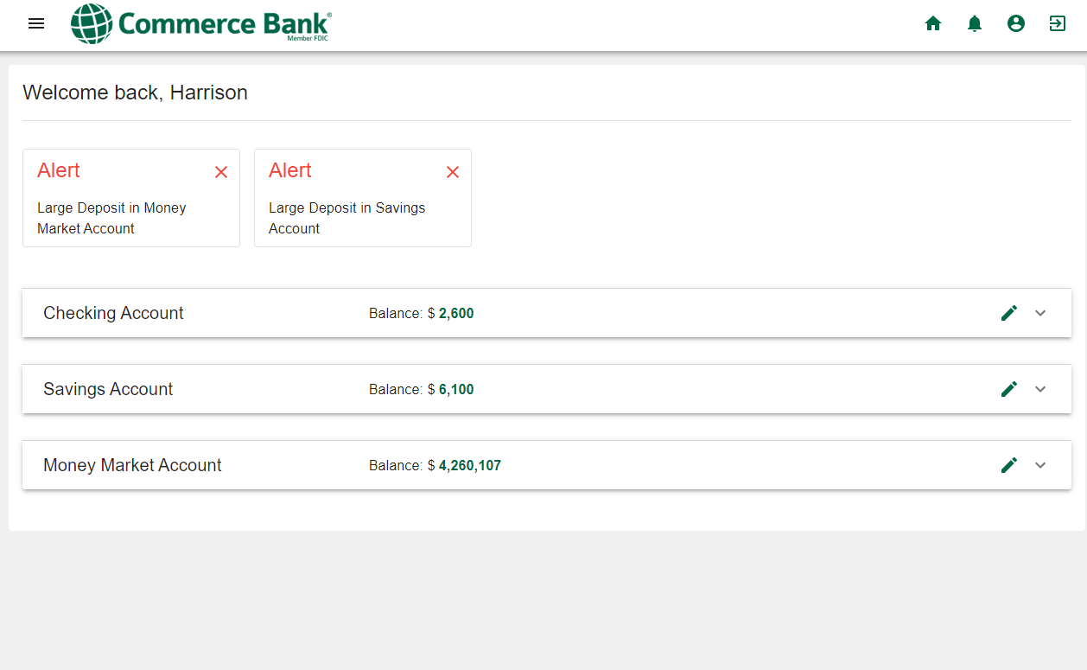
- To remove a notification, click the X at the top right of the notification.

Notification Preferences
- Navigate to Commerce Bank.
- Enter your username and password.
- Click the Login button.
- To manage your notification settings, click the Bell icon at the top right of the mega menu.

- Fill out the notification settings you would like to get alerts about and click Save.
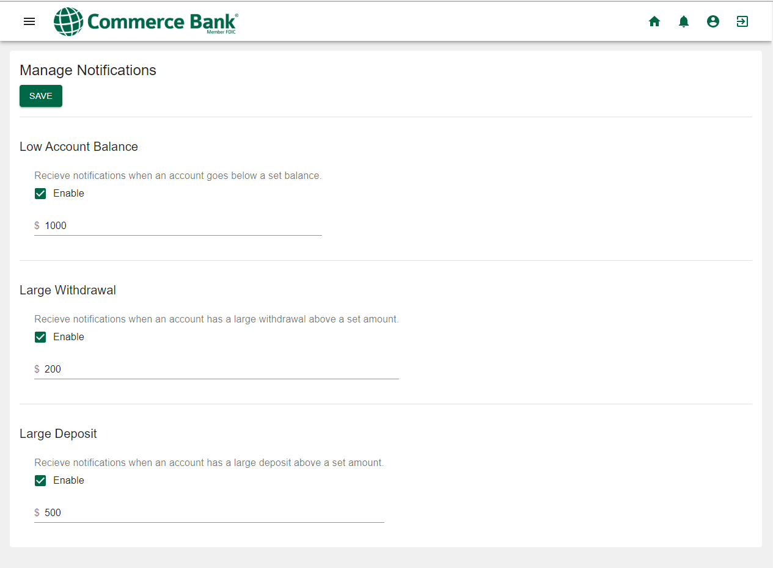
- To disable a notification setting, click the checkbox next to the setting and click Save

